**LAB PROJECT**

**DATABASE SYSTEM (CS-329)**

**SUBMITTED BY**

**MUNIB-UL-HASSAN CS19-037**

**MAAZ MOINDUDDIN CS19-042**

**ASJAD HUSSAIN RIZVI CS19-005**

**NAMIRA CS19-018**



**SUBMITTED TO**

**SIR ASIF RAZA**

**DEPARTMENT OF COMPUTER SCIENCE**

**SIR SYED UNIVERSITY OF ENGINEERING AND TECHNIOLOGY**

ERD

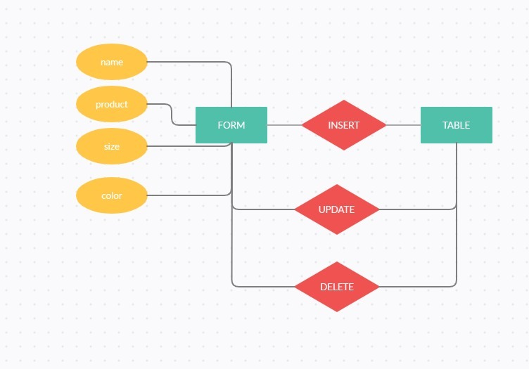

GET LIST OF ALL PRODUCTS

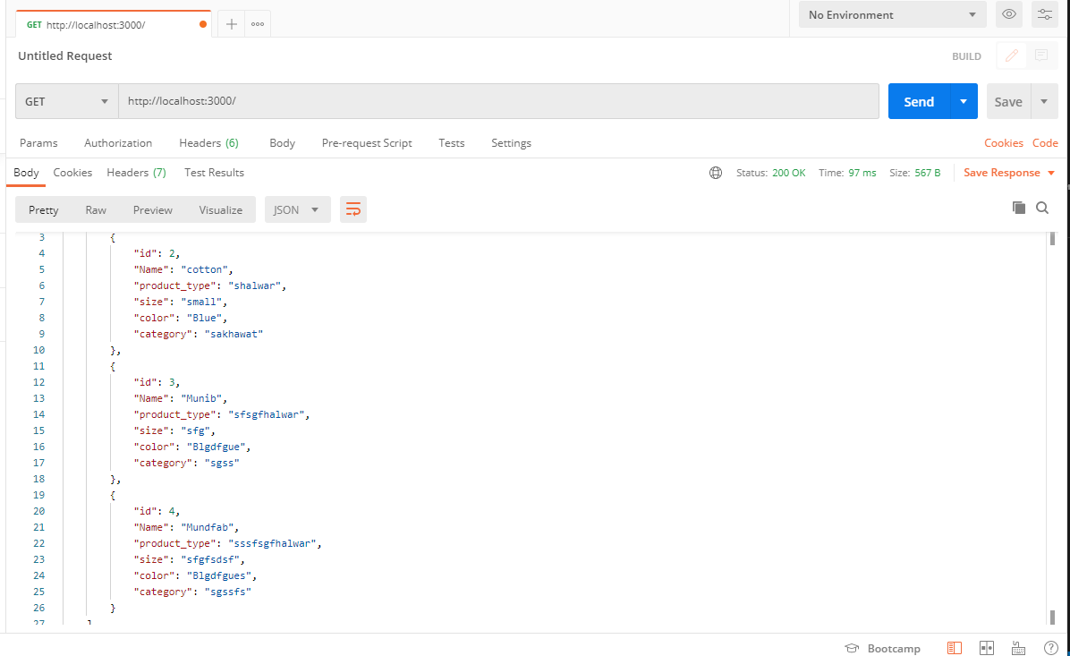

INSERT VALUES IN DB

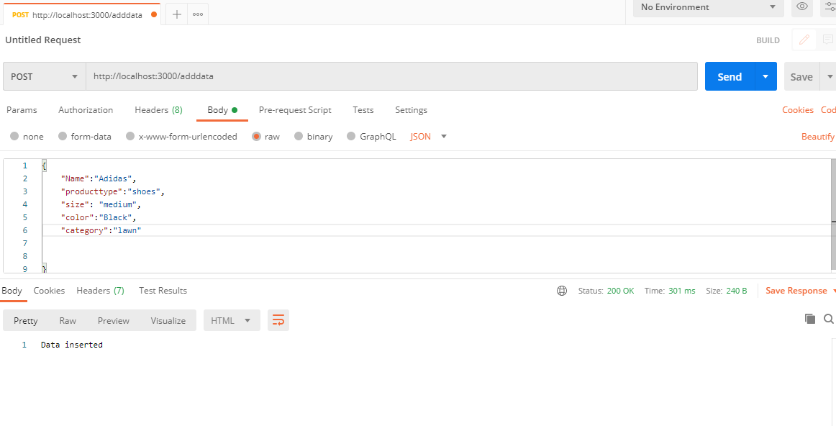

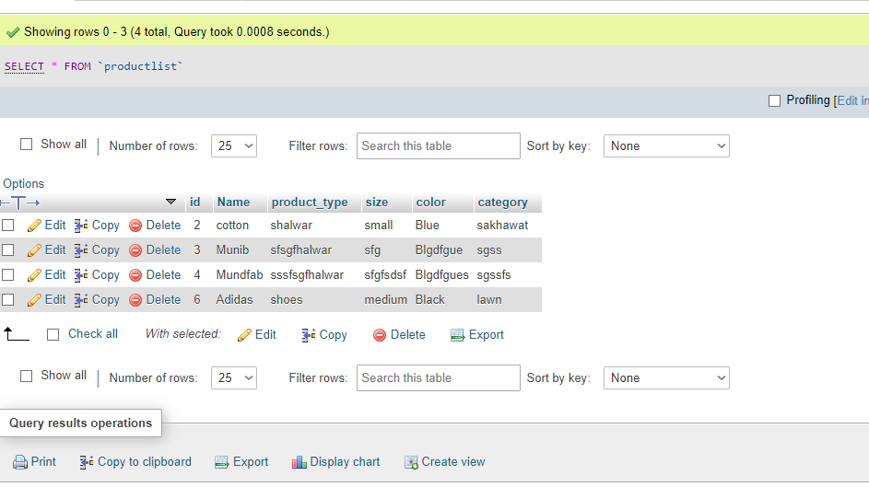

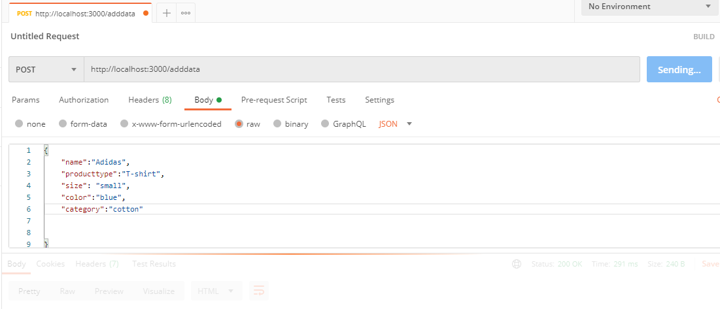UPDATE VALUES IN DB

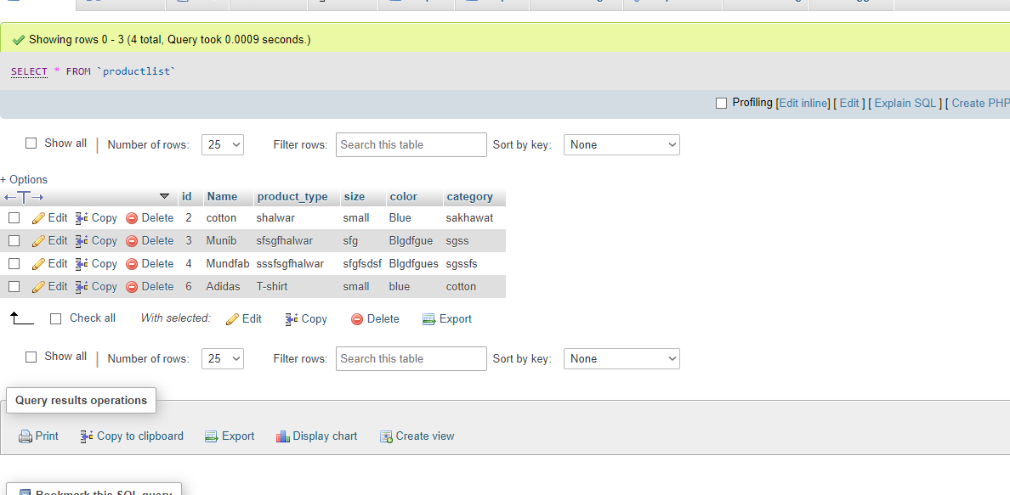

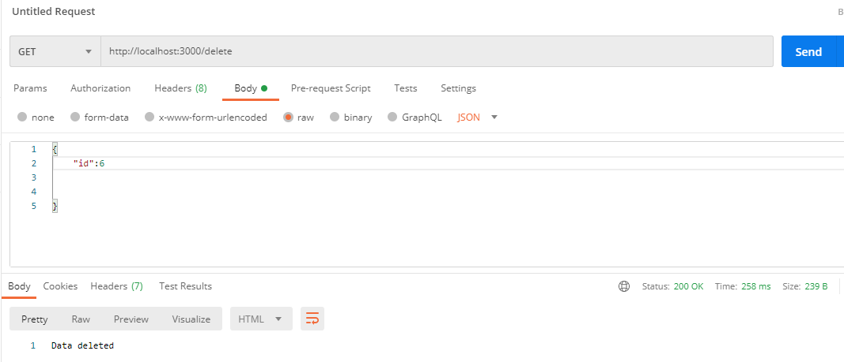 DELETE VALUES IN DB

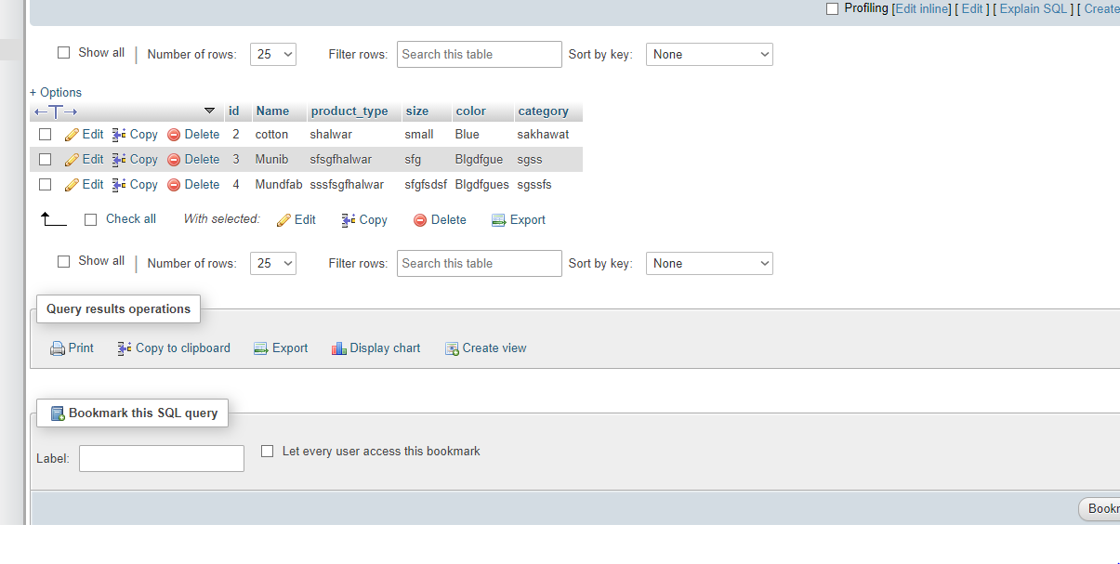 CODE

var express = require('express')

var user = new express()

var body = require('body-parser')

user.use(body.json());

var conect = require('./connection')

var sql = require("sql")

var mysql = require('mysql');

var con = mysql.createConnection({

  host: "localhost",

  user: "root",

  password: "",

  database:"DBproject"

});

con.connect(function(err) {

  if (err) throw err;

  console.log("Connected!");

});

// Create table

    user.get('/addtable', (req, res) => {

    let sql = 'CREATE TABLE Productlist(id int AUTO_INCREMENT, Name VARCHAR(255), PRIMARY KEY(id),product_type VARCHAR(255), size varchar(255), color VARCHAR(255),category varchar(255))';

    con.query(sql, (err, result) => {

        if(err) throw err;

        console.log(result);

        res.send('Posts table created...');

    });

});

user.post('/adddata',async (req,res,next)=>{

    var id;

    let sql = 'select * from productlist WHERE name = ?';

    let data = con.query(sql,[req.body.name],(err,result)=>{

        if(err) throw err;

        console.log(result);

        if(result.length<=0){

            let sql1= 'INSERT INTO productlist SET ?';

            let values = {

                Name:req.body.name,

                product_type:req.body.producttype,

                size:req.body.size,

                color:req.body.color,

                category:req.body.category };

            con.query(sql1,values,(err,result)=>{

                if(err) throw err;

                console.log(result);

                res.status(200).send("Data inserted")

            })

        }else{

            let sql2 = 'update Productlist SET name=?,size=?,color=?,category=?,product_type=? where name = ?';

            let values = [req.body.name,req.body.size,req.body.color,req.body.category,req.body.producttype,req.body.name];

            con.query(sql2,values,(err,result)=>{

                if(err) throw err;

                console.log(result);

            })

        }

    })

})

user.get('/delete',(req,res)=>{

    let sql= 'DELETE FROM PRODUCTLIST WHERE ID = ?'

    con.query(sql,[req.body.id],(err,result)=>{

        if(err) {

            console.log(err);

        }

        console.log(result);

        res.status(200).send("Data deleted")

    })

})

user.get('/',(req,res)=>{

    console.log("//");

    let sql = 'select * from productlist';

    con.query(sql,(err,result)=>{

        console.log(result);

        res.status(200).json({data:result})

    })

})

user.listen(3000,(err,reslt)=>{

    console.log("Server is running");

})